Underfitting and Overfitting in Deep Learning

Underfitting in Deep Learning
- Underfitting happens when a deep learning model is too simple to learn the underlying pattern in the data.
- The model fails to learn even the training data properly.

Characteristics
- Low training accuracy
- Low validation/testing accuracy
- High training loss
- Model learns very little
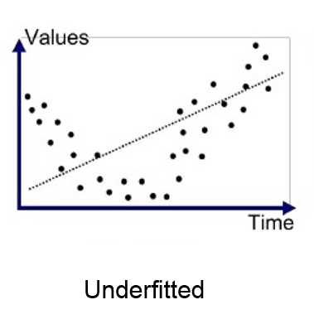
Causes of Underfitting
- Very simple network (few layers / few neurons)
- Too few training epochs
- High regularization (too much dropout, strong L1/L2)
- Poor feature representation
- Learning rate too high

How to Fix Underfitting
- Increase model complexity (more layers/neurons)
- Train for more epochs
- Reduce regularization
- Use better features
- Reduce learning rate if too high

Overfitting in Deep Learning
- Overfitting happens when a model learns the training data too well, including noise, but performs poorly on unseen data.
- The model memorizes instead of generalizing.

Characteristics
- Very high training accuracy
- Low validation/testing accuracy
- Validation loss increases
- Large gap between training & validation performance
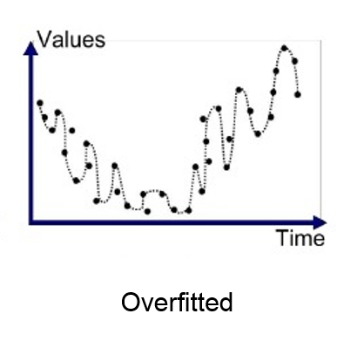
Causes of Overfitting
- Very deep or complex model
- Too many parameters
- Small dataset
- Training for too many epochs
- No or weak regularization

How to Fix Overfitting
- Use Dropout
- Apply L1/L2 regularization
- Use Early Stopping
- Increase training data (Data Augmentation)
- Reduce model complexity
- Use Batch Normalization

Underfitting vs Overfitting (Comparison Table)
Aspect | Underfitting | Overfitting
Model complexity | Too simple | Too complex
Training accuracy | Low | Very high
Testing accuracy | Low | Low
Generalization | Poor | Poor
Main issue | High Bias | High Variance

Bias–Variance Relation
- Underfitting → High Bias, Low Variance
- Overfitting → Low Bias, High Variance
- Best model → Balanced Bias & Variance

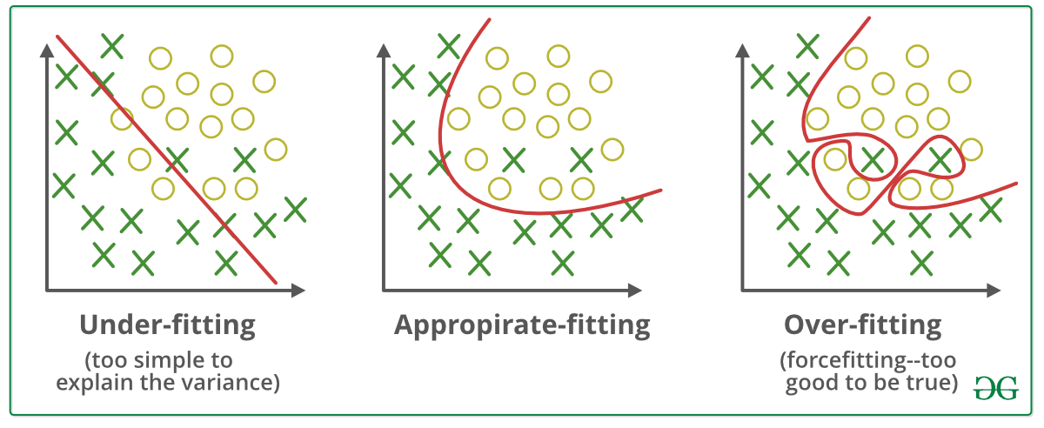

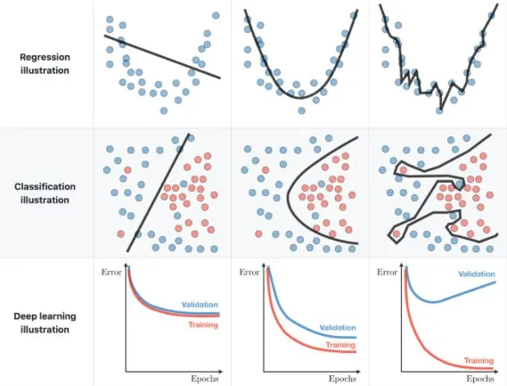

How to Identify Overfitting in Deep Learning
Overfitting is identified by comparing training and validation (Test) performance.

Key Signs of Overfitting
1. Training vs Validation Accuracy
- Training Accuracy: Very high (≈ 95–100%)
- Validation/Test Accuracy: Much lower
➡ Large gap = Overfitting

2. Training vs Validation Loss
- Training loss keeps decreasing
- Validation loss starts increasing after some epochs
➡ Strong indicator of overfitting

4. Model Behavior
- Performs very well on known data
- Performs poorly on unseen data

Simple Rule
If training improves but validation worsens → Overfitting

Early Stopping (Prevent Overfitting)
- Early stopping helps training automatically when validation performance stops improving.
- Prevents the model from memorizing training data.

How Early Stopping Identifies Overfitting
- Monitors validation loss
- Stops training when validation loss:
  - Stops decreasing
  - Starts increasing for several epochs
- keras.layers import Dense
- from keras.callbacks import EarlyStopping
- from keras.models import Sequential
- ann.fit(x_train,y_train, batch_size=100, epochs = 50, validation_data=(x_test,y_test), callbacks = Earlystopping())

Example
If validation loss doesn’t improve for 5 consecutive epochs, training stops.

Benefits
✔ Saves training time
✔ Improves generalization
✔ Simple and effective

Early Stopping Example (Concept)
Epoch 12 → Best validation loss
Epoch 13–17 → No improvement
Training stopped at Epoch 17

Regularization (Control Model Complexity)
- Regularization is a technique used to reduce overfitting by adding constraints to a deep learning model so that it generalizes well to unseen data.
- Regularization adds constraints so the model does not become too complex.
- It prevents the model from becoming too complex.

Why Regularization is Needed?
Without regularization:
- Model learns noise from training data
- Training accuracy is very high
- Test accuracy is low (overfitting)
With regularization:
- Model learns important patterns
- Better performance on new data

Types of Regularization Used to Identify & Reduce Overfitting
- L1 & L2 Regularization (Weight Penalties)

L2 Regularization (Weight Decay)
- Penalizes large weights
- Encourages smaller, smoother models
Loss Function:
Loss=Original Loss+λ∑w2

L1 Regularization
- Encourages sparsity (some weights become zero)
- Helps in feature selection
Loss Function:
Loss=Original Loss+λ∑∣w∣

How it Helps Identify Overfitting
- Without regularization → training accuracy very high
- With regularization → training accuracy slightly drops, validation improves

2. Dropout Regularization
- Dropout is a regularization technique where some neurons are randomly “turned off” (dropped) during training to reduce overfitting.
- The network is forced not to depend on specific neurons.++
Why Dropout is Needed?
In deep networks:
- Neurons become highly dependent on each other
- Model memorizes training data
- Leads to overfitting
Dropout solves this by:
- Breaking neuron co-adaptation
- Making the model more robust

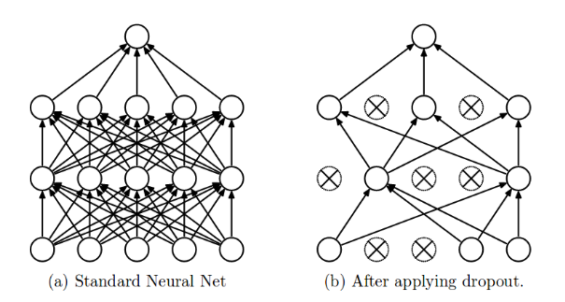
How Dropout Works
During Training:
- Randomly selects neurons
- Sets their output to zero
- Happens in every mini-batch
During Testing:
- No neurons are dropped
- Full network is used
- Weights are scaled automatically

Benefits of Dropout
✔ Reduces overfitting
✔ Improves generalization
✔ Acts like model averaging
✔ Easy to implement

🔹 Drawbacks
- Slower training
- Too much dropout → underfitting
- Not always suitable for very small models

“Dropout is a regularization technique where neurons are randomly deactivated during training to prevent overfitting and improve generalization.”
Dropout = Randomly remove neurons to make the network stronger

“Regularization is a technique to reduce overfitting by penalizing model complexity. Common methods include L1 and L2 regularization, Dropout, Early Stopping, and Data Augmentation.”
Early Stopping vs Regularization
Aspect | Early Stopping | Regularization
Purpose | Stop training early | Control model complexity
When applied | During training | During loss calculation
Prevents | Memorization | Over-complex models
Common types | Patience-based stop | L1, L2, Dropout

- Overfitting is identified when training accuracy is high but validation accuracy is low, and validation loss increases while training loss decreases.
- Early stopping prevents overfitting by stopping training when validation loss stops improving.
- Regularization techniques like L1, L2, and Dropout reduce model complexity and improve generalization.

